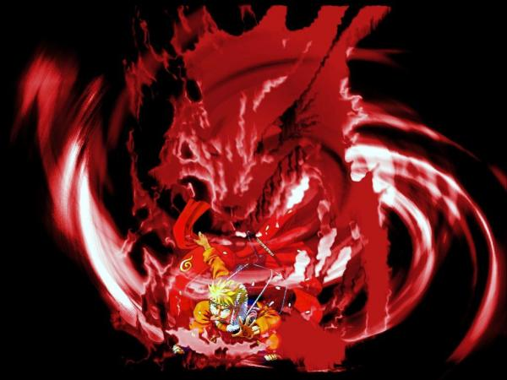

NARUTO – XBOX360

Chakra Bar

Revision History

VERSION | DATE | COMMENTS | By
1.0 | April, 10 2006 | Creation of the Document | H.Luck
1.1 | April 12, 2006 | Revision | H.Luck
1.2 | April 12, 2006 | Added Stamina etc | H.Luck
1.3 | April 13, 2006 | Removed conversion and made other changes asked for from meeting | H.Luck
1.4 | May 16, 2006 | Huge modifications to include changes to Chakra Bar System, gameplay loops and Mid / Low Level systems | Harry Luck

TABLE OF CONTENT

Revision History 2
TABLE OF CONTENT 3
1 Introduction 4
2 The Bar 4
3 Game States 4
4 Rebalancing Chakra 6
5 Chakra Use 6
6 Chakra Regeneration 7
7 Chakra Conversion 7
8 Experience and actions 7
9 Health as part of the Chakra bar 8
10 Control VS Speed (mid-level) 8
11 Skills and Techniques (low-level) 8

Introduction

- The Chakra Bar is an integral part of Naruto. Through Chakra Management the player will gain both Blue and Red Chakra experience.

- Both Blue and Red Chakra will act as the player’s health. Once the player is out of Chakra, he will be in a KO state (see KO system document)

- The Chakra Bar will track the players experience and unlock Techniques (see Techniques document)

- The Chakra Bar will be used to create the various Jutsus the player will use to defeat his enemies. This will use the players Chakra.

- The Chakra Bar will represent the players influence on the world.

The Bar

The Chakra Bar is split into two separate sides, Blue Chakra and Red Chakra.



Blue Chakra represents the player’s control and defensive techniques. Blue Chakra will reflect your helper state. People in the world will not respect you, but you will be accepted.

Red Chakra represents the player’s speed and offensive techniques. Red Chakra will reflect your monster state. People in the world will acknowledge your prowess and skill, but may be very frightened of you.

Techniques in Blue Chakra are purely defensive, passive or diversionary techniques. The results will depend on the type of Jutsu you choose to use. Red Chakra techniques are offensive in nature and are designed to stun, injure or kill the opponent. Chakra Management is thus vital, as, the player will need to keep a good balance between offensive and defensive techniques.

Both the Blue Chakra and the Red Chakra will act as your health. Once you run out of both, you will become KO’d.

Game States

The Dropout

At the beginning of the game, the player will be unable to access Red Chakra; this will help the player initially expand his Blue Chakra. The player has practically no experience, and as such he will be seen as a “dropout”. The “dropout” status is seen only at the beginning of the game and is reflected in the way the game world interacts with the player – NPC’s will disregard him, higher level missions will be locked and access to several items of note will not be available as of yet.

The Helper

When the bar is like the image above, the player is in total control (“helper”). Although the player will find it incredibly easy to unleash his high level Blue Chakra techniques, it will be slow to do so. He will also have practically no access to Red Chakra techniques making him very weak. The game world will treat the “helper” as someone who is acceptable, though not extraordinary. In this state the player will have limited access to ‘Ninja Missions’, the ‘Social Loop’ and could possibly be unable to continue his journey through the story until he has re-balanced his Chakra.

The Monster

In the state shown in the image above the player is totally out of control (“monster”). This player will find it very difficult to unleash his high level Red Chakra techniques, due to the erratic nature of being so unbalanced. He will have the speed and power, but no control. Due to this player’s little experience with Blue Chakra the player will not be able to defend well, which will be indispensable. The “monster” will be treated by the game world with respect but, people will be frightened of him. In this state the player will have limited access to ‘NPC Quests’, the ‘Personal Loop’ and could be unable to continue his journey through the story until he has re-balanced his Chakra.

The Hero
The key is Chakra Management to create balance (“hero”). In the image above the player has access to much Blue Chakra as well as Red Chakra. As such, the player may call upon an equal range of techniques in both Chakra fields, taking advantage of the benefits each may bring to any particular battle. This is the optimal game state to be in, and will be reflected as such in the way the game world interacts with the player, giving him a special status and above standard recognition for his hard work and achievements. It also allows him access to all side quests and will be the only way the player can complete 100% of all side quests throughout the game.

Rebalancing Chakra

By focusing on the Personal or Social Loop the player will be able to re-balance his Chakra slightly. However, there may be times when the player has gone too far and may need to seek out special trainings.

Through special Blue or Red Chakra training (mini-games) spread out in Konoha and the surrounding mission areas the player has visited, the player will be able to re-balance his chakra if he has become unbalanced. This way his experience could become more evenly divided, thus, balanced again (“hero”). However, during the course of the game these opportunities would be less available and have less impact thus making sure the player is aware that over time his actions and level of control will have permanent consequences.

Also note that allowing the player to keep an unbalanced chakra at this point in the game, when the learning curve is long past and the game system has been clearly established, means that players who actively seek the added challenge of ending the game in an unbalanced state may in fact do so, adding further playability to the game as a whole for advanced players, or those playing the game for a second time and seeking a different end game experience.

Chakra Use

When the player uses his techniques he will have to choose which Chakra type to use, he would do this by choosing Red Chakra techniques with the Left Trigger and Blue Chakra techniques with the Right Trigger. He will then create his hand-seal using the hand-seal system.

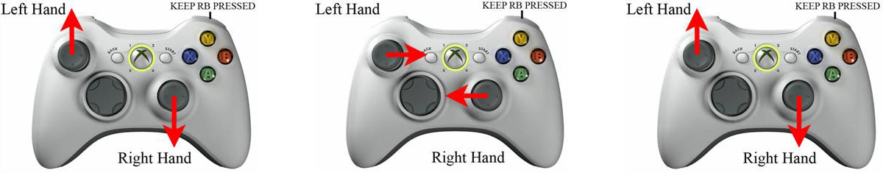

Once the hand seal is complete the player will see Naruto become silhouetted on the screen to show his Chakra flow. Dependant on the player’s experience, this will move differently (large Blue Chakra experience, slow but smooth, large Red Chakra experience, fast but erratic, Balanced, fast and smooth). The Chakra Bar will also show how much Chakra the technique will cost.


In the above example, you can see how much Blue Chakra it costs to do a simple “henge technique”.

INSERT CHAKRA BODY IMAGE

Above you can see an image of Naruto’s Chakra system (the players), this would be flowing in and out dependant on the players state. The player must release the trigger when all the Chakra has collected at the centre of his body.

It is important to note that with great experience in Blue and Red Chakra comes more controlled and faster movement of the Chakra within the body.
In the state above the player, although balanced he has little actual experience and is thus not skilled. The Chakra will flow slowly, and will not be perfectly smooth when doing so.
In the state show above the player is balanced but has high experience, and thus is highly skilled. The Chakra will flow quickly and extremely smoothly. This will make it quicker for the player to use his techniques (as he will improve naturally at doing the techniques throughout the game) and will make him much more adept in battle.

Chakra Regeneration

Throughout the game the player will be able to rest at Naruto’s home between missions and will be able to rest at specific spots during journeys to regain his Chakra.

However, in battle, the only way the player can regain Chakra is to use the Kyuubi. This is spirit of the demon fox within Naruto and is what allows him to regain his stamina so quickly and easily.

Here it will be a technique the player can use. However, the player must either, not be in combat, or make sure he is not disturbed (by using a defensive technique first) to use this technique. It will be level based and can be improved like any other technique.

This will only refill the players Red Chakra as it comes directly from the Kyuubi

Chakra Conversion

This is a technique that would allow the player to convert one type of Chakra into another. Especially useful if the player has just used the Kyuubi technique to regain his Red Chakra and wants to convert some of it into Blue Chakra.

This will also add to the Chakra Management for the player.

Experience and actions

The player will gain Red Chakra experience and Blue Chakra experience in several ways. Doing ‘Ninja Missions’, ‘NPC Quests’, ‘Special Quests’ and by using his techniques. The more the player leans towards using Blue Chakra for his battles the more his Blue Chakra experience will grow. This will create a natural imbalance in the player and his attitude, and so the world will react accordingly.

As previously stated, the player will be able to rebalance his Chakra, but only up to a point. The player should be held accountable for his actions in the game and over time it will become harder and harder to refocus the characters (and thus the players) balance to either Blue Chakra or Red Chakra. When the game gets to a point where Chakra rebalancing is a difficult proposition, it will have long been made clear to the player what the game system entails – it is still critical to allow the player the conscious decision to play with an unbalanced Chakra, if he so desires. One should note that this will greatly increase the challenge factor, possibly exponentially so, however.

Health as part of the Chakra bar

Firstly, from a design angle, I’d like to keep the screen as clutter free as possible. Secondly, I think the player can and should be able to quickly and easily see his state (health and chakra) as well as his available techniques with a simple glance in one place. The players focus should be on the action, not on some crazy HUD.

I also think it is good to link the Chakra to the player’s life due to the nature of Chakra and its use in the Naruto universe. Although I have removed the conversion process of Stamina to Chakra, I believe the two are so closely linked that one might as well be the other. Instead, allowing the player to focus on Chakra Management which will reflect his acts during combat and his actions in the world to promote our feeling of Self Control. We would also be creating the feeling of Self Control when the player has to actually try and use his seals and techniques.

It is important to note that damage taken will currently be evenly distributed between Blue and Red Chakra.

Control VS Speed (mid-level)

Blue Chakra is control. The more experience the player gains in Blue Chakra, the more control the player will have whilst using his techniques. The gameplay will be much easier. However, too much Blue Chakra without Red Chakra will make the gameplay easy but slow for the player to use his techniques.

Red Chakra is speed. The more experience the player gains in Red Chakra, the more speed the player will have whilst using his techniques. The gameplay will be quicker for the player to pull off. However, too much Red Chakra without Blue Chakra will make the gameplay fast but extremely erratic for the player to use his techniques.

The more experience you gain in both Chakra fields will have an effect on how the technique gameplay will work for the player.

Skills and Techniques (low-level)

The player will unlock skills through expanding his Chakra Bar with experience.

Blue Chakra is the player’s defensive techniques only and will include techniques like, running on water and creating clones to confuse the enemy. The more the player uses his Blue Chakra techniques the more Blue Chakra experience he will gain.

Red Chakra is also the player’s offensive techniques only and will include techniques like, creating chakra infused kunai and shadow replications. The more the player uses Red Chakra techniques, the more Red Chakra experience he will gain.

It is up to the player to decide when and what Chakra to use, the key is Chakra Management. The more balanced the players Chakra, the techniques the player has access to will be more even and his techniques will also be easier to use without failure.

The skills will be unlocked in a two ways. Some through the story, but others as the players experience grows. The story and missions will have to be used to help control the experience the player can gain, thus allowing us to know when and how the story based techniques can be unlocked.

