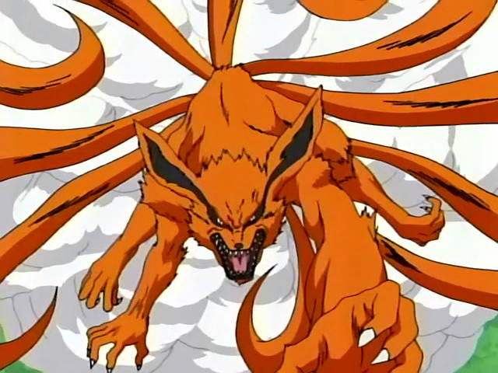

NARUTO – XBOX360

FOX System

Revision History

VERSION | DATE | COMMENTS | By
1.0 | May 2, 2006 | Creation of the Document | Harry Luck
1.1 | May 4, 2006 | Additions to further explain system | Harry Luck
1.2 | May 16, 2006 | Added effects of being in the FOX state as well as making minor changes due to the Chakra Bar changes | Harry Luck

TABLE OF CONTENT

Revision History 2
TABLE OF CONTENT 3
1 Introduction 4
2 FOX Gameplay 4
3 The FOX Icon 5
4 Unleashing the FOX 5
5 FOX and Friends 6

Introduction

This document will cover the FOX system. Its intention is to give the player the possibility to unleash the power of the FOX through skillful use of the player’s fighting techniques and defenses.

The player will have a FOX Icon that slowly fills up. When it does the player will have the opportunity to use a special RED CHAKRA technique to unleash the FOX.

FOX Gameplay

To fill the FOX Icon the player must be skillful in combat. Only RED techniques can add to the FOX Icon as well as TaiJutsu, Weapons and the skillful use of the replacement technique. Combo’s will be rewarded with a higher addition to the Icon.

You must reach 1000 points inside the FOX Icon for it to be filled.

Ex:

1x TaiJutsu Hit = +1 point
3x TaiJutsu Hit = +3 points
1x 2 Hit TaiJutsu Combo = +8 points (2(combo hit)+2(combo hit)x2(2 hit combo))
1x 6 Hit TaiJutsu Combo = +72 points (6(combo hit)+6(combo hit)x6(6 hit combo))

You will also gain points from blocking or dodging enemy attacks.

Ex:

Block = +3 points
Dodge = +5 points
Replacement = +10 points
Replacement + Counter = +25 points

However, the player can also lose FOX Icon points by being hit. These will be dependant on the type/size/power of the hit.

Ex:

Taijutsu Hit = -1 point
Replacement + Counter = -10 points
Fire Technique = -20 points

Ex:

Start Combat:

Player hits enemy with 2 Hit TaiJutsu Combo (+8)
Player blocks enemy Hit (+3)
Player hits enemy with 6 Hit TaiJutsu Combo (+72)
Player is hit with Fire Technique (-20)
Player hits enemy with 3 TaiJutsu Hits (+3)
Player Replacement + Counters enemy (+25)

End Combat:

Player receives a total of 91 FOX Icon points.

This will all have to be further defined once we have a clearer idea of how exactly we intend the Combat System to work.

But, for the most part the player will have to work skillfully and tactically during combat to increase his FOX Icon and thus bring him closer and closer to the awesome power it contains.

The FOX Icon

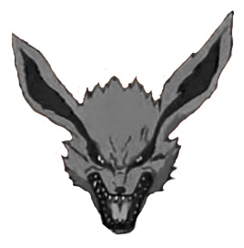
The FOX icon will represent how close (or far away) the player is to being able to unleash the FOX.

Above, the FOX icon is empty.
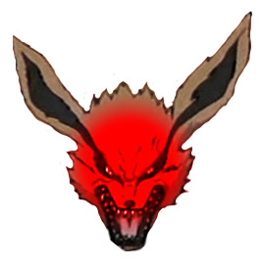

And above here, the player has filled his FOX Icon half way.

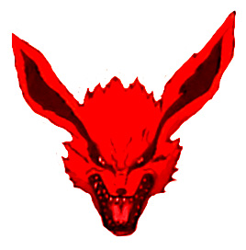

And lastly, the above shows a fully ready FOX Icon. It should be glowing, or fiery or something similar when it is full.

Unleashing the FOX

To unleash the FOX the player must pull both Chakra Triggers together at once when the FOX Icon is full.

It will be the same game-play as unleashing any normal technique; however, there will be no ping-pong game-play. It will only require a simple hand-seal. The amount of FOX Chakra you have will be based on how many “friends” the player has obtained from doing NPC Quests, and how quickly the player can bash his button (this is what will replace the ping-pong game-play).

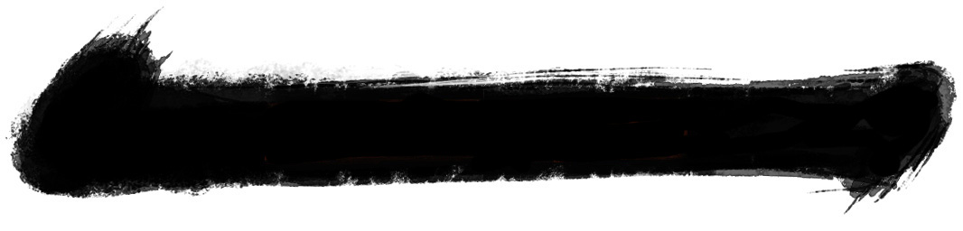
The Chakra Bar will empty completely, and the player will begin to bash his (A) button

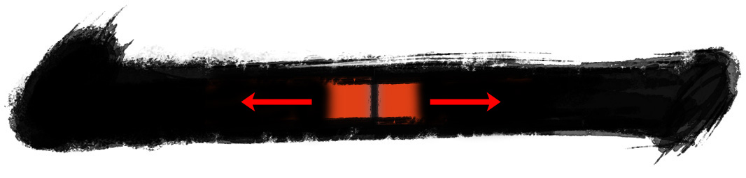

You will see Naruto on-screen becoming the FOX as you bash your buttons, the world around you in a relative pause. Here you will be able to see the FOX’s Chakra expanding in the now empty Chakra bar.

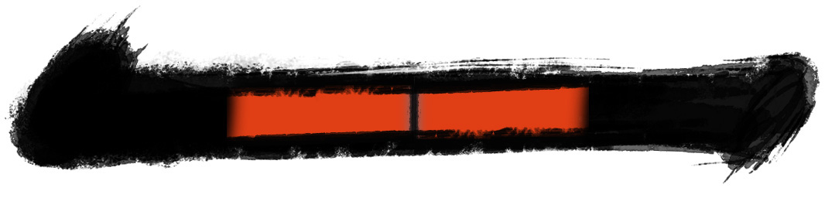
Above we can see that the player has gained 50% of his FOX Chakra during his button mashing. He has now completely transformed into the FOX and has all the power to destroy his enemies!
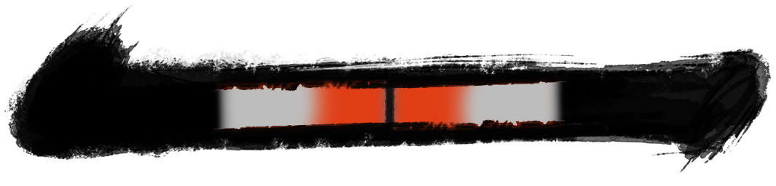Here, the Chakra is decreasing. This happens not only by using techniques, but also over time, the Chakra will diminish. 6.5 points per second from either side of the Chakra bar. This roughly translates as 1 minute as the FOX if you have full experience, the total number of required “friends” and the nimble button fingers to achieve this. The grey areas shown beneath the FOX Chakra is the player’s previous Chakra state before becoming the FOX.

Once the player loses all his FOX Chakra, the player will return to the state he was prior to unleashing the FOX. The players Chakra will be as it was before he became the FOX.

FOX and Friends

The amount of FOX Chakra the player can gain from unleashing the FOX is based on how many “friends” the player has.

Each “friend” the player gains will give him +1 second to bash his buttons to gain FOX Chakra.

Ex:

2x “friends” = 2 seconds / 10% health maximum
5x “friends” = 5 seconds / 25% health maximum

These are examples and could be changed based on how many NPC Hidden Quests we have. And how many “friends” the player can actually gain in total by the end of the game.

FOX Effects

When the player has unleashed the FOX a number of effects will occur.

- The player will have a FOX aura around him (orange/red glow)
- The surrounding environment will slow down (bullet-time style) to give the player a feeling that the FOX is incredibly fast
- The player will no longer have access to techniques
- The player will only be able to use Taijutsu and Weapons, but with devastating effect (x4 damage)
- The player can only dodge and counter attack with the replacement technique (regardless of level) and will do x4 damage also
- The player will be more destructive to his environment.

