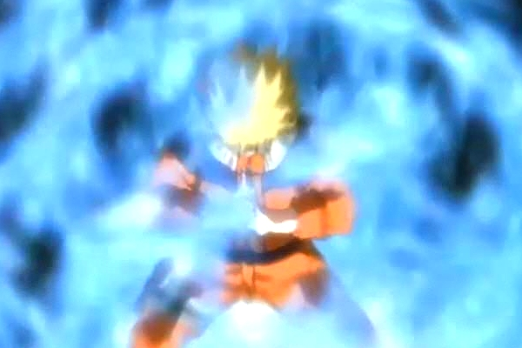

NARUTO – XBOX360

Techniques (Powers)

Revision History

VERSION | DATE | COMMENTS | By
1.0 | April, 24 2006 | Creation of the Document | Harry Luck
1.1 | May 3, 2006 | Modifications and additions | Harry Luck

TABLE OF CONTENTS

Revision History 2
TABLE OF CONTENTS 3
1 Introduction 4
2 Explanations 4
2.1 Hand-to-Hand Combat (TaiJutsu) 4
2.2 Sexy Technique (Sexy No Jutsu) 4
2.3 Replacement Technique (GenJutsu) 5
2.4 Disguise Technique 5
2.5 Clone Technique 5
2.6 Shadow Replication Technique 6
2.7 Chakra Concentration Technique 6
2.8 Dispel Technique 7
2.9 Summoning Technique 7
2.10 Kyuubi System 8
3 Technique Representation Onscreen 8
3.1 Technique Layout In Chakra Bar 8
4 Learning New Techniques 9
4.1 Hand Seals Gameplay 9
4.2 Timing (ping-pong gameplay) 9
5 Improvement Game Systems / Ideology 10
5.1 Adaptive Difficulty 10
5.2 Mini-Games 10
5.3 Levels 11
5.4 Mission Certificates 11
6 Training Examples 12
6.1 Chakra Concentration Training 12

Introduction

This document will cover the techniques the player can unlock during the course of the game. It will also include the improvements (or levels) for those techniques as well as the effects they will have with Blue Chakra, Red Chakra or the Fox State.

Explanations

Hand-to-Hand Combat (TaiJutsu)

Levels = 1 hit Combo (level 1) to 6 hit Combo (level 6)
OR 1x Combo (level 1) to 6x Combo (level 6)
1x speed (level 1) to 2x speed (level 6)
1x damage (level 1) to 1.5x damage (level 6)

BLUE = 1x damage (+level) 1x speed (+level)
Chakra Use = 0

RED = 2x damage (+level) 2x speed (+level)
Chakra Use = 2.5

FOX = 4x damage, 4x speed
Chakra Use = 5

FAIL = counter-attack against you possible if you miss your attacker

Weapon Technique (kunai etc)

Levels = 2x Throwing Star/Kunai (level 1) – 6x Throwing Star/Kunai (level 3) (damage
x1)
4x Smoke Kunai (level 4) – 6x Smoke Kunai (level 5) (damage x1.5)
6x Explosive Kunai (level 6) (damage x3)
1x Speed (level 1) to 2x speed (level 6)

BLUE = 1x damage (+level)
1x speed (+level)
Chakra Use = 0

RED = 2x damage (+level)
2x speed (+level)
Chakra Use = 5

FOX = 4x damage
4x speed
Chakra Use = 10

FAIL = miss your attacker

Sexy Technique (Sexy No Jutsu)

Levels = 10% Sexy Effect Chance (level 1) 100% Sexy Effect Chance (level 6)
1x Sexy No Jutsu Replications (level 1-3)
3x Sexy No Jutsu Replications (level 4) (Shadow Replication Prerequisite)
4x Sexy No Jutsu Replications (level 5) (Shadow Replication Prerequisite)
5x Sexy No Jutsu Replications (level 6) (Shadow Replication Prerequisite)

BLUE = Sexy Effect (+level) (only on men)
Chakra Use = 2.5

RED = .5x Sexy Effect (+level) (only on men)
2x Sexy No Jutsu Replications (level 4-6 only) (harem no jutsu)
Chakra Use = 2x

FOX = 0% Sexy Effect (+level) (only on men)
.5x Sexy No Jutsu Replications (level 4-6 only)
Chakra Use = 4x

FAIL = 1x really ugly sexy no justsu (no effect)

Replacement Technique (GenJutsu)

Levels = Dodge (level 1-2)
Dodge + Replacement (2-4) (causes enemy confusion, 2 secs?)
Dodge + Replacement + Counter-Attack (level 5-6) (causes enemy confusion,
3secs?)
x1 speed (level 1) x2 speed (level 6)
x1 damage (level 5-6)

BLUE = 1x speed (+level)
1x damage (levels 5-6)
Chakra Use = 5

RED = 1.5x speed (+level)
2x damage (levels 5-6)
Chakra Use = 2x

FOX = Dodge + Counter Attack Only
2x speed (+level)
4x damage (levels 5-6)
Chakra Use = 4x

FAIL = No dodge or replacement (puff of smoke but stay in the same place)

Disguise Technique

Levels = Fool Genin & Civilians (level 1-2) (time=5-10 seconds)
Fool Chuunin (level 3-4) (time=15-20 seconds)
Fool Jounins (level 5-6) (time=25-30 seconds)

BLUE = Chakra Use = 10

RED = 50% Chance Failure
Chakra Use = x2

FOX = 75% Chance Failure
Chakra Use = x4

FAIL = mismatch disguise of target

Clone Technique

Levels = 10% Clone Effect (level 1) to 50% Clone Effect (level 6)
1x Clone (level 1)
1x Clone + Taunt (Effect +5%) (level 2)
1x Clone + Taunt (Effect +5%) + Translocation (Effect +10%) (level 3)
3x Clone (level 4) (Shadow Replication prerequisite for multiple clones)
3x Clone +Taunt (Effect +10% each) (level 5)
3x Clone + Taunt (Effect +10% each) + Translocation (Effect +25%) (level 6)

BLUE = 1x Effect (+level)
Chakra Use = 15
Clone Effect = enemy confusion (10% - 100% based on level)

RED = .75x Effect (+level)
2x Clone (+level) (if have Shadow Replication)
1.5x Speed
Chakra Use = 2x
Clone Effect = enemy confusion (7.5% - 75% based on level)

FOX = .5x Effect (+level)
4x Clone (+level) if have Shadow Replication)
2x speed (+level)
Chakra Use = 4x
Clone Effect = enemy confusion (5% - 50% based on level)

FAIL = a clone that clearly looks nothing like Naruto

Shadow Replication Technique

Levels = 5 TaiJutsu replications (level 1)
Rendan (5 replication Combo) (level 2)
Bunshin Gachandou (5 replication Body Slam) (level 3)
Shihou Hapou Shuriken no Maki (10 replication Shuriken Cyclone) (level 4)
Nisen Rendan (25 Hit Combo) (in the show it’s 2000) (level 5)
Yonsen Rendan (50 Hit Combo) (in the show it’s 4000) (level 6)
BLUE = 1x damage
1x speed
Chakra Use = 25

RED = 1.5x damage
2x speed
2x replications
Chakra Use = 2x

FOX = 3x damage
4x speed
4x replications (mass shadow replication)
Chakra Use = 4x

FAIL = floppy Naurto replication (like the one in the show)

Chakra Concentration Technique
Levels = 10 feet run up trees (level 1) to 100 feet run up trees (level 6)
10 seconds run on water (level 4) to 60 seconds run on water (level 6)

BLUE = 1x speed
1x height/time
Can use TaiJutsu and Techniques while on water
Chakra Use = 30

RED = 1.5x speed
.5x height/time
use TaiJutsu and Techniques while on water
Chakra Use = x1

FOX = 2x speed
.25x height/time
Can only use TaiJutsu while on water
Chakra Use = x1

FAIL = will fall in water or run up tree and fall down

Dispel Technique

Levels = 25% Chance / 1 person (level 1)
50% Chance / 1 person (level 2)
100% Chance / 1 person (level 3)
50% Chance / AOE (level 4)
100% Chance / AOE (level 5)
100% Chance / AOE / 25% Chance Reversal (level 6)

BLUE = Chakra Use = 40

RED = Chakra Use = 40
% Chance /2

FOX = Chakra Use = 40
% Chance /4

FAIL = fail to Dispel the illusion, possibly believes in the actual illusion

Summoning Technique

Levels = Summon x1-3 Gamakichi Frog (level 1-3)
Summon x1-2 Armour (level 4) (speed x1 level 4 to speed x1.5 level 5)
Summon Gamabunta (level 6)

BLUE = Gamakichi Frog will give you useful advice
Armor Frog (protects you) (speed x1.5 +level)
Chakra Use = 50

RED = Gamakichi Frog = Stun Frog will give advice and protect you by stunning
nearby enemies
Armour Frog = Attack Frog (will attack any enemies nearby) (speed x1.5
+level)
Chakra Use = x2
Gamabunta (level 6 only) – Chakra Use = x4

FOX = Cannot Summon while in FOX State

FAIL = create tiny cute tadpole

Kyuubi System

Levels = Regeneration 0.1%/sec (level 1) to 1%/sec (level 6)

The Kyuubi inside Naruto is what allows him (in the show) to take great
damage and heal so quickly. For us it will work as a system of
Auto-Regeneration (think regen in FFVII) and can be upgraded like any technique with a mini-game training.

Technique Representation Onscreen

Technique Layout In Chakra Bar
Here you will find a representation of the Chakra Bar and where (experience wise) the player will be able to unlock techniques, this will also be heavily reliant on the story also, but mainly, it’s purely based on the players experience.
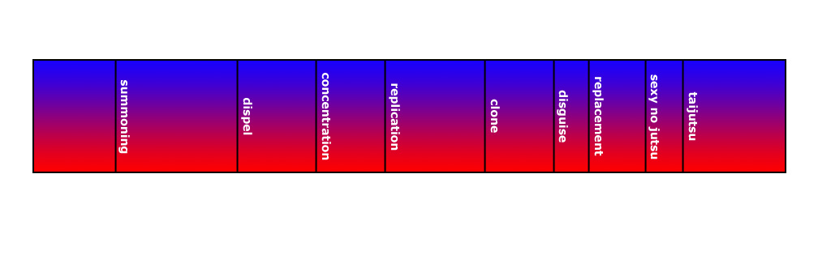
The above shows where the techniques are physically unlocked along the Chakra Bar. The techniques will be unlocked through the players experience in Blue / Red Chakra. If the player unlocks Shadow Replication through Blue Chakra experience, then he will have access to Mass Shadow Replication in Red Chakra (however, this will be dependant on how much Red Chakra experience the player has). It is important to note two things. Firstly, the size of the Chakra block is not representative of how much chakra that technique will cost to use, but the amount of experience the player needs (or needed) to unlock that technique. Secondly, the Taijutsu technique represents where the player begins the game, and will have this much chakra and that technique from the start of the game.
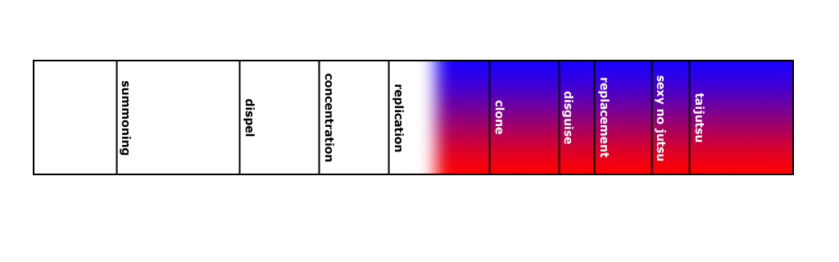
The above image shows a representation of a player’s current experience in Blue and Red Chakra. He would be able to see something like this in a menu, not on the screen while he is playing. The black techniques represent currently locked techniques.

Learning New Techniques

To learn techniques we will ask the player to perform the actual technique but in a mini-game style environment, to firstly, try and make it fun, but secondly, to try and get the player to memorize the technique quickly and easily. The player must complete the task below 5 times, each time could get a little harder, or a little faster, but… I think the most important thing is to simply get the player to successfully repeat the process a number of times to get it into his head well.

Hand Seals Gameplay
This will be done like DDR. We will ask the player to follow the on screen commands as they scroll down the screen which will mimic the actual thumb-stick directions that the player needs to do to complete that hand-seal.

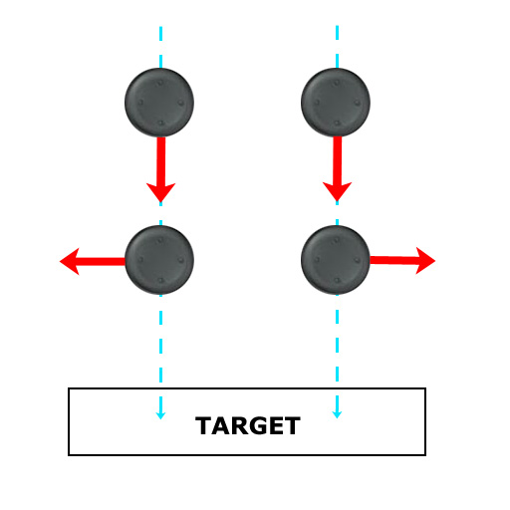
The player must pull down his Left Trigger, when he does, the game-play will begin.

It is here we will ask the player to follow the on screen prompts and when the thumbstick images reach the “TARGET” destination, when they do, he must push the pictured thumbsticks in the suggested direction as quickly and accurately as possible.

It is very important that the player can quickly and easily understand the system, and by using this simple exercise help the player keep the specific technique controls in his memory.

Timing (ping-pong gameplay)
As soon as the player has correctly input the last two thumbstick commands, depending on the players experience state (“helper” / “monster”) “RELEASE” will begin to come down the screen at a speed based on that state.

If the player is a “monster” then the “RELEASE” message will be extremely quick and will not come at a constant rhythm, to simulate how the player will actually have to do this technique in his current state.

If the player is in “helper” state, his message will come very slow and smooth. Again, this is to simulate how the player will have to deal with this when he tries to use it in the field.
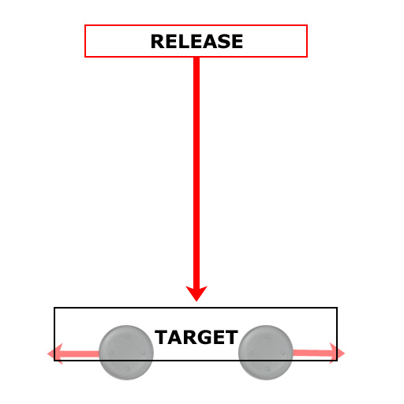
However, the player needs to complete all 5 within a certain time.

When it’s in the correct place, the player must release his Left Trigger to complete the move. At the same time you are suppose to release the button, your trainer will also shout, “RELEASE”.

If the player has done everything correctly, he will finally get to see his new technique in action! ☺

Once the player has successfully completed this task 5 times, he gains his new technique and has had the hand-seals drilled into his memories so it is not complicated for him to pull of his techniques in the heat of battle.

Improvement Game Systems / Ideology

This will cover the mini-games the player must complete to improve his current techniques. When the player first learns a technique it will always begin at level 1, and the player can only improve this techniques by completing another stage of each of the mini-games for each technique. Each and every mini-game should essentially be a simple, button-mashing or thumbstick control type of gameplay.

Adaptive Difficulty
The difficulty of each mini-game should be adaptive based on the players input. With the example of the “Chakra Concentration” (tree climbing / water walking) the player may go nuts the first time mashing his buttons like crazy to get up the tree, but fail. Then, doing the same thing again, he seems to get a little higher, and again, he gets even higher, and so on. The player still feels like he’s working like crazy, and although he is probably improving, the game is also taking a little bit of the heat off the player. This will give the player a feeling of determination.

Mini-Games
The mini-games should be based on the technique the player is trying to improve.

Ex:

TaiJutsu: Player must destroy special Hidden Leaf Village Ninja Rock
Shadow Replication: Player must control his Chakra first and the use his hand seals before quickly having to place where his Shadow Replications will go before the timer runs out.

Chakra Concentration: Player must reach 30 meters up tree (level 1)

1st try : Adaptive Difficulty = 100% (player must do 5 button presses/sec)
Player only reaches 8 meters.

2nd try : Adaptive Difficulty = 100% (player must do 5 button presses/sec)
Player reaches 10 meters.

To bring the difficulty down to 75% as a prerequisite the player MUST reach 10 meters minimum.

3rd try : Adaptive Difficulty = 75% (player must do 4 button presses/sec)
Player reaches 15 meters.

To bring the difficulty down to 50% as a prerequisite the player MUST reach 15 meters minimum.

4th try : Adaptive Difficulty = 50% (player must do 3 button presses/sec)
Player reaches 26 meters.
5th try : Adaptive Difficulty = 50% (player must do 3 button presses/sec)
Player reaches 30 meters.

TRAINING COMPLETE

The player is not restricted to only complete the task at the easiest difficulty %, if he is fast enough, he maybe able to complete the task after the 1st try. However, the initial task should not be possible, so that we can make the training feel extremely hard to the player initially.

Levels
Each Technique has 6 levels of improvement. As such, each mini-game will require the player to work harder for each level. Each mini-game will need 6 levels of difficulty, and require the player to complete a similar but slightly altered task than the last level.

Ex:

Chakra Concentration: Player must reach 150 meters up tree (level 6)

1st try : Adaptive Difficulty = 100% (player must do 10 button presses/sec)
Player only reaches 67 meters.

2nd try : Adaptive Difficulty = 100% (player must do 10 button presses/sec)
Player reaches 75 meters.

To bring the difficulty down to 75% as a prerequisite the player MUST reach 75 meters minimum.

3rd try : Adaptive Difficulty = 75% (player must do 7 button presses/sec)
Player reaches 90 meters and must press A to jump past a hole in the tree
Player reaches 100 meters.

To bring the difficulty down to 50% as a prerequisite the player MUST reach 100 meters minimum.

4th try : Adaptive Difficulty = 50% (player must do 4 button presses/sec)
Player reaches 90 meters and must press A to jump past a hole in the tree
Player reaches 123 meters.
5th try : Adaptive Difficulty = 50% (player must do 4 button presses/sec)
Player reaches 90 meters and must press A to jump past a hole in the tree
Player reaches 130 meters and must press X to swing past a branch to the other side of the tree.
Player doesn’t press the X button in time and falls.

6th try : Adaptive Difficulty = 50% (player must do 4 button presses/sec)
Player reaches 90 meters and must press A to jump past a hole in the tree
Player reaches 130 meters and must press X to swing past a branch to the other side of the tree.
Player reaches 150 meters.

TRAINING COMPLETE

Mission Certificates
The player will require Mission Certificates to take to his trainers to be able to spend them to improve his techniques.

The Mission Certificates are only achievable from completing Hokage Missions (D,C,B) or by completing Story Missions.

Improvement Costs:

Level 2 = 1x D certificate
Level 3 = 2x D certificate
Level 4 = 1x C certificate
Level 5 = 2x C certificate
Level 6 = 1x B certificate + 1x C certificate

Training Examples

Chakra Concentration Training

