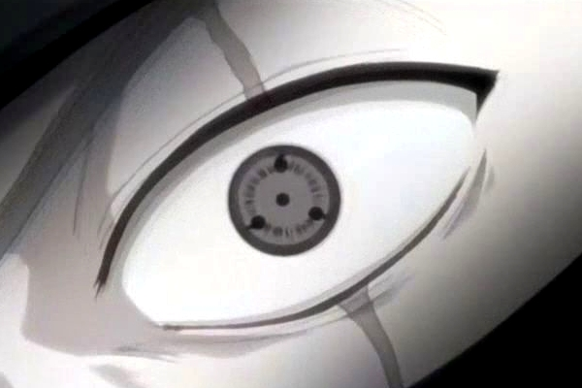

NARUTO – XBOX360

Lock on system

Revision History

VERSION | DATE | COMMENTS | By
1.0 | May, 5 2006 | Creation of the Document | Harry Luck

TABLE OF CONTENT

Revision History 2
TABLE OF CONTENT 3
1 Introduction 4
2 Locking On 4
3 Switching Targets 9

Introduction

This document is designed to cover the basic principles of our Lock-On System. Most of this will be pictorial, with brief explanations to make it clearer what is going on in the pictures.

The lock-on system itself is automatic in nature, no buttons need to be pressed to select or change your target. It is a similar system to that used in PoP2 but with a slightly more intuitive way to fight multiple enemies.

Locking On

GREEN = Naruto / Naruto’s Movement
BLACK = Enemy position
RED = Primary Lock Target
BLUE = Secondary Lock Target(s)
CYAN = Camera
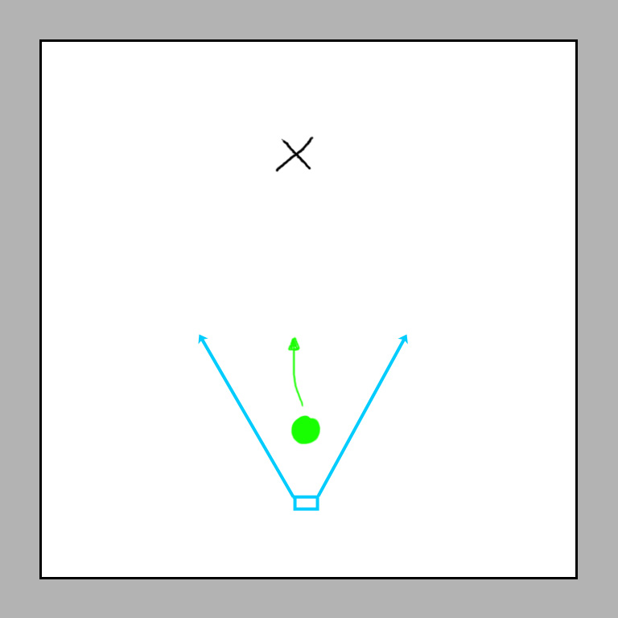

Above Naruto (the player) has moved into a combat situation. An enemy is ahead of him, but is not yet close enough to become a Locked-On Target. The Camera is thus staying behind Naruto to allow him to keep seeing where he is heading.

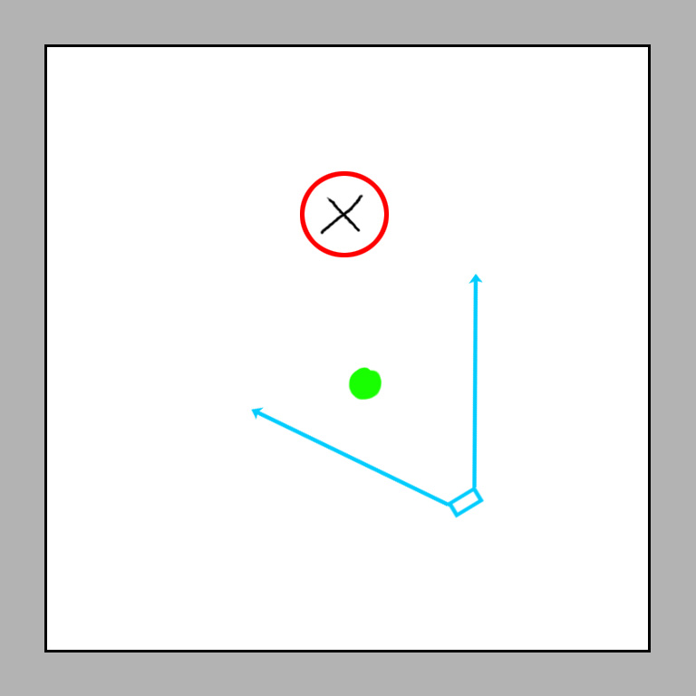

Naruto has got close to the enemy and has now become Auto-Locked to Enemy #1. The player now has a Primary Target (red circle). The camera is beginning to turn to face the two fighters side on, so the player can better see what he is doing while fighting.

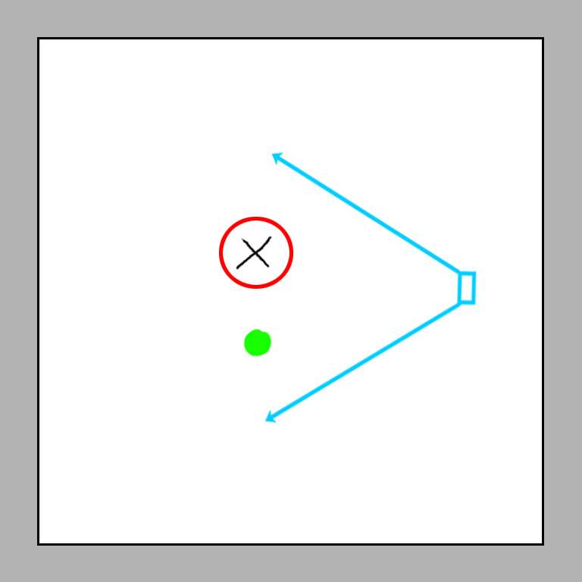

The Camera has reached its final position and the player has already begun to kick some enemy butt. Unless the player now runs away from the enemy for a fair distance, the player will remain Locked to his Primary Target (red circle)

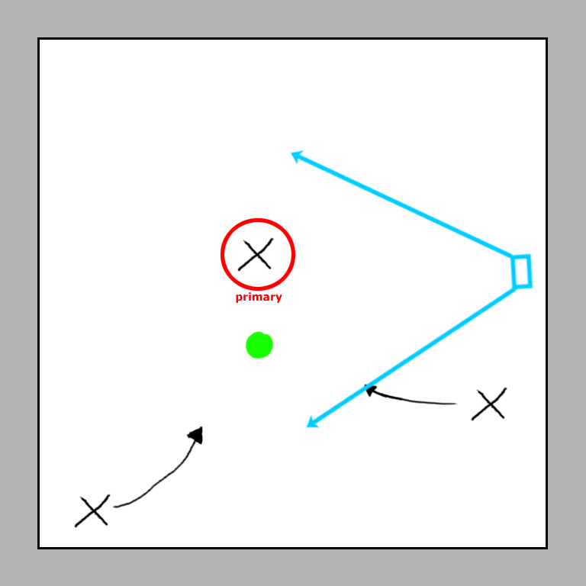

2 more enemies are now arriving to the rear of the player. The Camera adjusts and zooms out slightly to try and get the coming enemies into shot so the player is better aware of his situation.

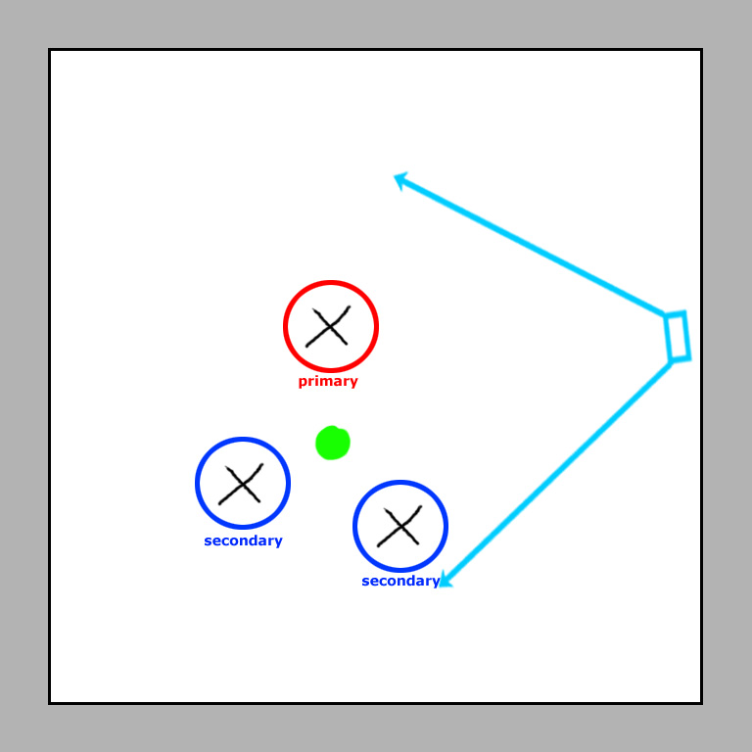
The enemies have got close enough to the player while he is fighting his Primary Target to become Secondary Targets (blue circles). From here the player can not only use straightforward combat to attack his Primary Target but he can also use his movement thumb-stick to make attacks go towards either of the Secondary Targets. Also the Camera has zoomed out further still and rotated slightly to allow the player to clearly see all three enemies; however, it is still trying to stay side on to the fight between the player and his Primary Target.

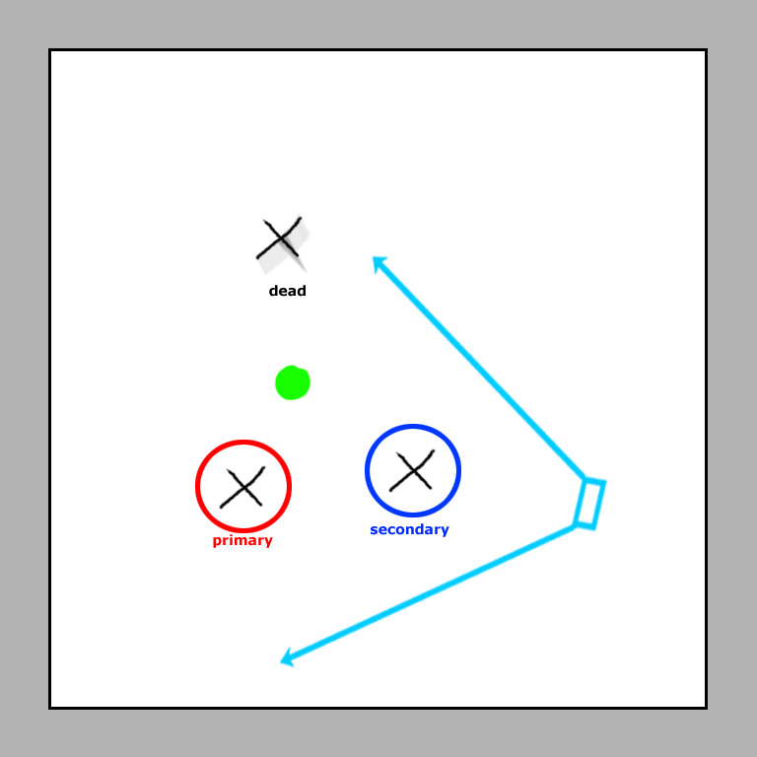

The player kills his Primary Target and the lock-system automatically switches the Primary Target to the next best enemy (closest, deadliest etc). The Secondary Target remains and the Camera once again re-orients slightly to better show the player versus his new Primary Target.

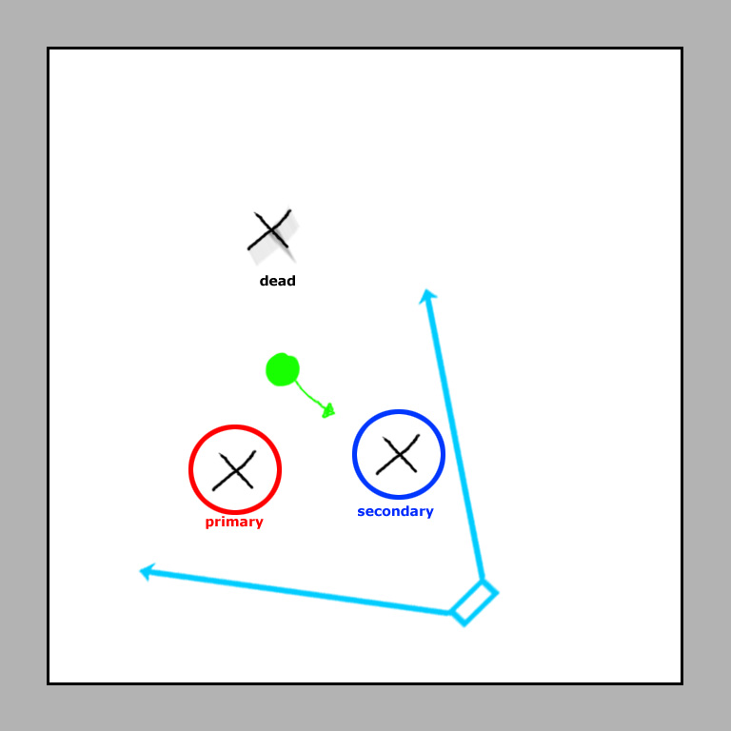

Here the player is pulling his thumb-stick towards his Secondary Target and not initiating combat with the Primary Target. The player holds his direction this way and begins to attack the Secondary Target.

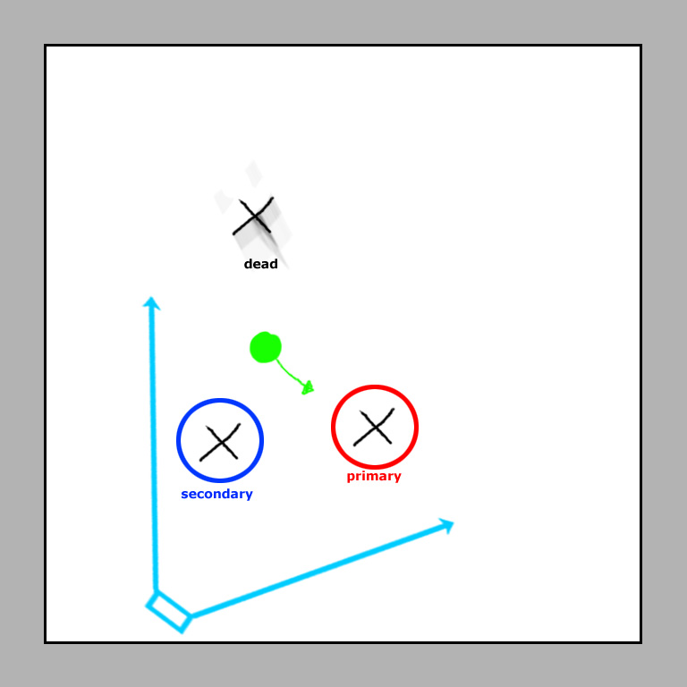

After holding his direction for over 1 second, the Primary Target automatically switches to the old Secondary Target. The Primary Target from before has now become the Secondary Target. The Camera reorients itself accordingly again.

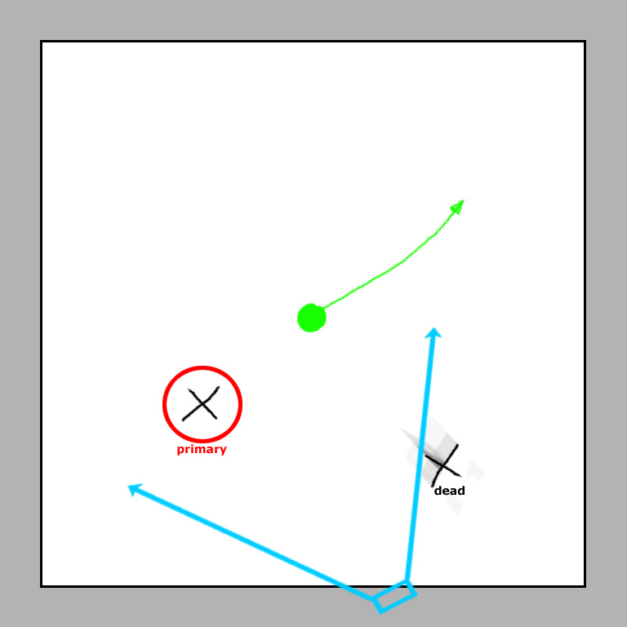

The player kills the Primary Target and this makes the final enemy automatically become the new Primary Target. The Camera reorients again, however… the player begins to run away.

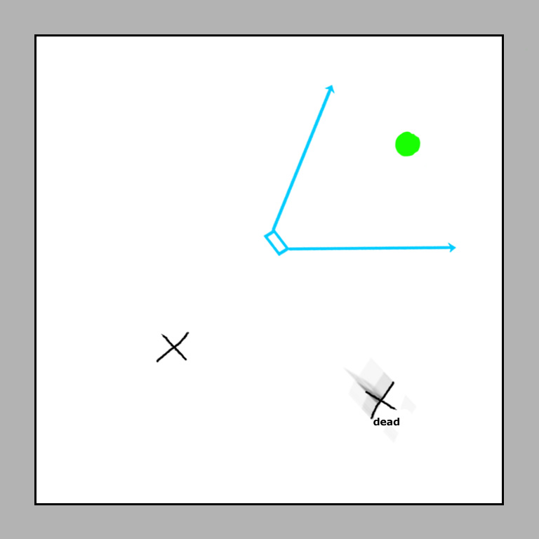

When the player has run far enough away the Auto-Lock is released and the Camera swings back behind the player into its normal traveling position.

Switching Targets

This section is only to clarify the Target Switch system. There is no button to do this, and it is only automatic if the player defeats his current Primary Target. In order for the player to switch from his Primary Target to a Secondary Target he must have a Secondary Target within range.

To switch the player must simply direct his attacks towards the Secondary Target instead of the Primary Target and keep doing so for a second or two. Then the Lock AI will automatically switch the Primary Target to the enemy the player is most focusing on.

