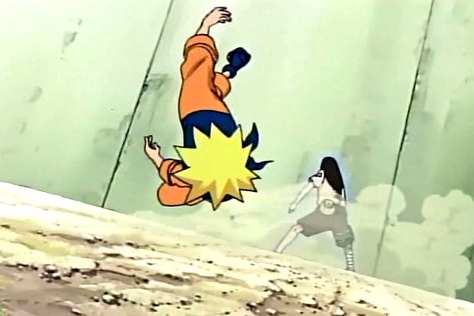

NARUTO – XBOX360

KO System

Revision History

VERSION | DATE | COMMENTS | By
1.0 | April, 14 2006 | Creation of the Document | O. Palmieri
1.1 | May 2, 2006 | Modifications to KO System | Harry Luck
1.2 | May 3, 2006 | Add minimum timing and “friends’ lives” name. Modify pictures. | O. Palmieri
1.3 | May 3, 2006 | Modifications to “friend” systems and added difficulty section. | Harry Luck

TABLE OF CONTENT

Revision History 2
TABLE OF CONTENT 3
1 Introduction 4
2 Explanations 4
3 Friends – time & chakra 5
4 On screen 5
4.1 Naruto’s Shadow Appear – Gameplay starts 6
4.2 After 3 seconds, Player sees first “Friend’s Icon” 6
4.3 One second later, player sees second “Friend’s Icon” 7
4.4 Player fills channels in time - success 7
4.5 Naruto is back on feet with 10% chakra 8
5 Difficulty 8
6 Bullet points 11

Introduction

When Naruto has no more Blue/Red Chakra, he falls down and becomes Knocked-Out.

To get back on his feet, and to give the player the feeling of determination, the player must unleash his remaining Stamina and convert it into Chakra.

As with most fighting games, to get back up from K.O, the player will only need to press repeatedly on the buttons.

Our system is based on this, but adds the idea of determination.

By asking the player to gain more “friends” and thus, “friends’ icon” to make it easier for him to return from KO will also give to the player an idea of acceptance.

Explanations

The player is in KO state when he has no more Blue and Red Chakra in his Chakra Bar.

Once KO’d, the player sees a shadowed representation of Naruto on-screen. The center of this shadow appears in the form of a green circle, Naruto’s hidden inner stamina.

From this green circle start many grey channels which extend to the entire body of Naruto.

The player always starts with a minimum of 3 seconds to complete the gameplay (but with this minimum timing and no friends, it is only possible to return from KO once).

After the minimum timing, the “friends’ icons” the player has gained will appear around the image of Naruto and tell him to get up etc. The amount of “friends’ icons” you have will determine the time the player has to mash the buttons to get back up. The more time the player has, the more likely he is to return from a KO.

If the player succeeds, then he will come back to life from the KO with a % of Chakra depending on how many “friends” he has. Each “friend” the player has will gives him 5% of his Chakra.

Gameplay:

The player is KO’d

The player must now press repeatedly on the A button with the time he has available (minimum of 3 sec).

The time the player has available will depend on the player’s number of “friends’ icons”. 1 “friend’s icon” is worth 1 second.

As the player presses the A button, the Stamina (green circle) will start to fill the channels.
Note: During the time the player is pressing the A button, if he loses speed while pressing the button the Stamina will begin to retreat back to the centre of the Stamina (green circle).

When the Stamina has filled the channels totally, Naruto will come out of the KO with a % of Chakra relative to the number of “friends’ icons” he has. (10 “friends’ icons” will give the player 100% of his Chakra back).

Each time the player is KO he will lose 1 “friend’s icon”. This means the player will lose 1 second of time during his next KO.

Note: This does not mean the player LOSES a “friend”, he will only lose a “friends’ icon”. So, the player will still get back up from a KO with the same amount of Chakra, but will have less time to get up from the KO to start with.

The determination is expressed by two concepts:

- The player has to quickly press a button the amount of time he has acquired based on his number of “friends’ icons”. He must have determination to completely fill the channels in the Naruto shadow.

- Each time the player is KO’d, the task of getting up will get harder and harder dependant on the number of “friend’s icons” the player has.

Friends – time & chakra

“friends”
Friends give the player 2 things:

Each “friend” will give the player 5% Chakra after getting up from a KO
Each “friend” will also give the player a “friends’ icon” (or a memory). This gives the player +1 second while the player is trying to return from a KO.

A “friend” is permanent. Once a “friend” is made, the player will never lose a “friend” and that “friend” will always add 5% health to the players Chakra after returning from a KO.

Ex:
The player has 5 “friends”, returns from a KO, the player will still have 5 “friends” and so he will receive 25% Chakra.

A “friends’ icon” is impermanent. After returning from each KO the player will lose 1 “friends’ icon”, meaning the player will have 1 less second to return from KO the next time he is knocked down.

Ex:
The player has 5 “friends’ icon” (or +5 seconds), when he returns from the KO he will lose 1 “friends’ icon”, and so the next time he is KO, he will only have 4 “friends’ icons” (or +4 seconds).

The player will see each of these “friends’ icons” pass by the Naruto shadow saying positive things; each one will last for 1 second. This will reinforce the idea of determination, as well as visually showing the player his acceptance.

You gain “friends” by completing NPC Quests.

On screen

Naruto’s Shadow Appear – Gameplay starts

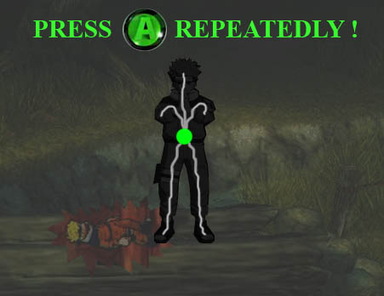

Gameplay Start. The player has to mash the “A” button to fill the Channels with his Stamina.

After 3 seconds, Player sees first “Friend’s Icon”

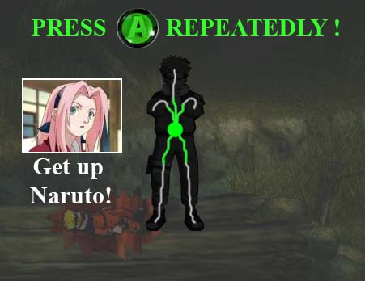

After 3 seconds, icons of his friends appear on screen.
His friend Sakura gives the player 1 more second to get up.

One second later, player sees second “Friend’s Icon”

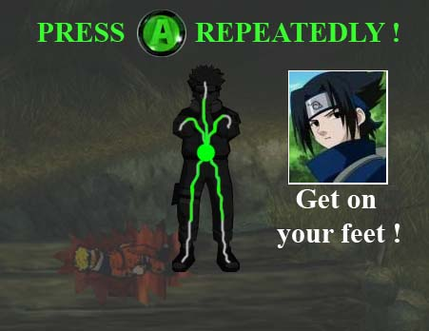

After one more seconds (Sakura memory), player sees another “Friend’s icon”.
His friend Sasuke gives the player 1 more second to get up.

Player fills channels in time - success

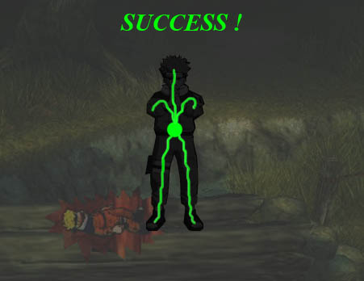

Player succeeds in filling completely the channels in time. It’s a success.

Naruto is back on feet with 10% chakra
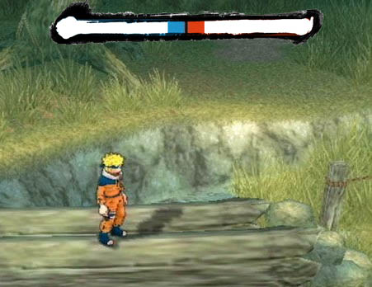

As the player has two “friends”, he can get back up with 2x5% = 10% Chakra.

Difficulty

Each time the player uses a KO the task of getting up should get harder and harder until the player rests. If the player is getting up for the 5th time, it should begin to become practically impossible. The KO difficulty is cumulative until the player goes to rest at Naruto’s house.

Ex:

This example is showing what would happen with each number of “friends’ icons” if the player continued to try and get up after each KO during one session of gameplay.

No “friends’ icon”
1st KO : 3 seconds = Player can return from a KO fairly easily.
2nd KO : 3 seconds = Player cannot return from KO.

1x “friends’ icon”
1st KO : 4 seconds = Player can return from a KO easily.
(player loses “friends icon”)
2nd KO : 3 seconds = Player can barely return from KO.
3rd KO : 3 seconds = Player cannot return from KO.

2x “friends’ icon”
1st KO : 5 seconds = Player can return from a KO easily.
(player loses “friends icon”)
2nd KO : 4 seconds = Player can return from KO fairly easily.
(player loses “friends icon”)
3rd KO : 3 seconds = Player cannot return from KO.

3x “friends’ icon”
1st KO : 6 seconds = Player can return from a KO easily.
(player loses “friends icon”)
2nd KO : 5 seconds = Player can return from KO fairly easily.
(player loses “friends icon”)
3rd KO : 4 seconds = Player can barely return from KO.
(player loses “friends icon”)
4th KO : 3 seconds = Player cannot return from KO.

4x “friends’ icon”
1st KO : 7 seconds = Player can return from a KO very easily.
(player loses “friends icon”)
2nd KO : 6 seconds = Player can return from KO.
(player loses “friends icon”)
3rd KO : 5 seconds = Player can barely return from KO.
(player loses “friends icon”)
4th KO : 4 seconds = Player cannot return from KO.
(player loses “friends icon”)
5th KO : 3 seconds = Player cannot return from KO.

5x “friends’ icon”
1st KO : 8 seconds = Player can return from a KO very easily.
(player loses “friends icon”)
2nd KO : 7 seconds = Player can return from KO fairly easily.
(player loses “friends icon”)
3rd KO : 6 seconds = Player can return from KO.
(player loses “friends icon”)
4th KO : 5 seconds = Player can barely return from KO.
(player loses “friends icon”)
5th KO : 4 seconds = Player cannot return from KO.
(player loses “friends icon”)
6th KO : 3 seconds = Player cannot return from KO.

6x “friends’ icon”
1st KO : 9 seconds = Player can return from a KO super easily.
(player loses “friends icon”)
2nd KO : 8 seconds = Player can return from KO fairly easily.
(player loses “friends icon”)
3rd KO : 7 seconds = Player can return from KO.
(player loses “friends icon”)
4th KO : 6 seconds = Player can barely return from KO.
(player loses “friends icon”)
5th KO : 5 seconds = Player cannot return from KO.
(player loses “friends icon”)
6th KO : 4 seconds = Player cannot return from KO.
(player loses “friends icon”)
7th KO : 3 seconds = Player cannot return from KO.
7x “friends’ icon”
1st KO : 10 seconds = Player can return from a KO super easily.
(player loses “friends icon”)
2nd KO : 9 seconds = Player can return from KO easily.
(player loses “friends icon”)
3rd KO : 8 seconds = Player can return from KO fairly easily.
(player loses “friends icon”)
4th KO : 7 seconds = Player can return from KO.
(player loses “friends icon”)
5th KO : 6 seconds = Player can barely return from KO.
(player loses “friends icon”)
6th KO : 5 seconds = Player cannot return from KO.
(player loses “friends icon”)
7th KO : 4 seconds = Player cannot return from KO.
(player loses “friends icon”)
8th KO : 3 seconds = Player cannot return from KO.

8x “friends’ icon”
1st KO : 11 seconds = Player can return from a KO super easily.
(player loses “friends icon”)
2nd KO : 10 seconds = Player can return from KO easily.
(player loses “friends icon”)
3rd KO : 9 seconds = Player can return from KO fairly easily.
(player loses “friends icon”)
4th KO : 8 seconds = Player can return from KO.
(player loses “friends icon”)
5th KO : 7 seconds = Player can barely return from KO.
(player loses “friends icon”)
6th KO : 6 seconds = Player cannot return from KO.
(player loses “friends icon”)
7th KO : 5 seconds = Player cannot return from KO.
(player loses “friends icon”)
8th KO : 4 seconds = Player cannot return from KO.
(player loses “friends icon”)
9th KO : 3 seconds = Player cannot return from KO.

9x “friends’ icon”
1st KO : 12 seconds = Player can return from a KO super easily.
(player loses “friends icon”)
2nd KO : 11 seconds = Player can return from KO very easily.
(player loses “friends icon”)
3rd KO : 10 seconds = Player can return from KO fairly easily.
(player loses “friends icon”)
4th KO : 9 seconds = Player can return from KO.
(player loses “friends icon”)
5th KO : 8 seconds = Player can barely return from KO.
(player loses “friends icon”)
6th KO : 7 seconds = Player cannot return from KO.
(player loses “friends icon”)
7th KO : 6 seconds = Player cannot return from KO.
(player loses “friends icon”)
8th KO : 5 seconds = Player cannot return from KO.
(player loses “friends icon”)
9th KO : 4 seconds = Player cannot return from KO.
(player loses “friends icon”)
10th KO: 3 seconds = Player cannot return from KO.

10x “friends’ icon” (maximum?)
1st KO : 13 seconds = Player can return from a KO super easily.
(player loses “friends icon”)
2nd KO : 12 seconds = Player can return from KO very easily.
(player loses “friends icon”)
3rd KO : 11 seconds = Player can return from KO fairly easily.
(player loses “friends icon”)
4th KO : 10 seconds = Player can return from KO easily.
(player loses “friends icon”)
5th KO : 9 seconds = Player can return from KO.
(player loses “friends icon”)
6th KO : 8 seconds = Player can barely return from KO.
(player loses “friends icon”)
7th KO : 7 seconds = Player cannot return from KO.
(player loses “friends icon”)
8th KO : 6 seconds = Player cannot return from KO.
(player loses “friends icon”)
9th KO : 5 seconds = Player cannot return from KO.
(player loses “friends icon”)
10th KO: 4 seconds = Player cannot return from KO.
(player loses “friends icon”)
11th KO: 3 seconds = Player cannot return from KO.

Bullet points

- Simple concept, close to other fighting games.

- Easy to understand in the heat of the battle.

- Harder and harder gameplay: determination.

- Takes few seconds, so fully compatible with VS Fight (opponent doesn’t have to wait for a long time).

- Enjoyable button-mashing gameplay.

