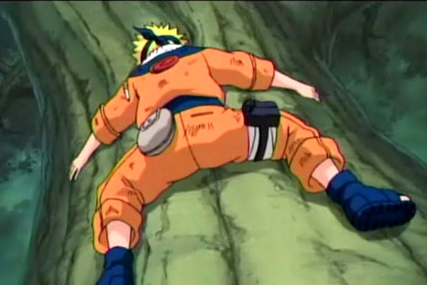

NARUTO – XBOX360

Tree Action Sequences

Revision History

VERSION | DATE | COMMENTS | By
1.0 | May 10, 2006 | Creation of the Document | Harry Luck
1.1 | May 16, 2006 | Changes to make the system more dynamic and less Action Event based | Harry Luck

TABLE OF CONTENTS

Revision History 2
TABLE OF CONTENTS 3
1 Introduction 4
2 How it works 4
3 Sequence Types 4
3.1 Travel 4
3.2 Chasing 4
3.3 Chased 4
4 Player Control and Movement 5
5 Action Events and Gameplay 5
5.1 Action Events 5
5.2 Other Gameplays 5
6 Examples 6

Introduction

This document is designed to explain what the tree action sequences are, what they will contain in terms of content and gameplay and how the player will physically play these sequences.

These action sequences should be a cross between Wipeout, SSX and any game with Action Events (AE).

How it works

The action sequences push the player to always be moving. The player cannot slow down or speed up; he can only direct Naruto along the path ahead of him. The pace should feel intense and make the player feel the need for urgency.

The only places the player can stop are on leafy plateau’s (see episodes 77-79). These will be the player’s checkpoints.

If the player falls at any point, whether through hitting an obstacle or falling while fighting he will land on a simple, larger leafy plateau and will have to face combat before making his way back to where he was and continuing his ‘flight’.

These sequences should begin with nothing more than asking the player to move from one place to another, and as the game progresses will begin to put obstacles in the way of the player the he must avoid or use, as well as adding enemies to impede the players progress. However, this should not undermine the feeling of intensity we require the player to feel.

Sequence Types

Three gameplay types are currently in mind.

Travel
Chasing
Chased

Travel

This mode will purely ask the player to quickly get from A to B. He will have to avoid obstacles and watch the onscreen prompts to jump, climb, throw a weapon etc.

Chasing

This will have the player chasing an enemy (or multiple enemies). Once he catches up with them, he will have to fight them. This will include all of the above obstacles and prompts also. While chasing the player will prompted at times to use the environment to hinder the enemy he is chasing.

Chased

This mode will involve having the player chased by an enemy (or group of enemies). He will have to move even quicker than usual. If he is caught, he will have to fight the enemy, win and then continue. The chase will then continue. While being chased the player may have to dodge thrown weapons and use the environment ahead of him wisely to slow down or stop the enemy following him.

Player Control and Movement

The player will use the Right Thumbstick to move through the sequence. Essentially there will be multiple paths and the player must (almost like a racing game) steer his character in the right direction(s). All jumps between branches will be.

Right Thumbstick = Left, Right, Up and Down through the environment / balance during slides.
A button (press) = Flying Punch
B button (press) = Roll / Block
X button (press) = Flying Kick
Y button (press) = Special Jump
LB button (press) = Fire Shuriken / Kunai
RB button (press) = Dodge / Substitution

Action Events and Gameplay

Action Events

Action Events (AE) will be moments where the player must use his context relative buttons to do things during the AE. While playing the game normally, the player must press Y to jump, this… if the player must do a huge leap while in the AE he will know he has to press Y to jump. All buttons will reflect this ideology. They will be similar to the Quick Time Events seen in games like Resident Evil 4 and Shenmue, but will instead use onscreen actions rather than onscreen buttons to cue the player as to what they should be doing. Most situations will have more than one way of doing it.

These should not be long cut-scenes where the player is just pressing buttons. The player must choose his paths and have occasional small obstacles that he must avoid using the AE system.

Ex:

Player is moving from tree to tree, suddenly a branch from a tree ahead of the player begins to break, when the player gets closer it suddenly breaks and the player must press A, X, LB or RB to either destroy or dodge the object that is falling. If the player successfully presses the button(s), then the character will be able to continue, however, if he doesn’t press the correct button(s) in time, he will hit the branch and fall with it, requiring the player fight.

Other Gameplays

Sliding (player must use thumbstick to balance while sliding on branch or other object)

This is like grinding in Tony Hawk or SSX, you must balance Naruto as he briefly slides a down or along a branch (or other object).

Run Up Obstacle (player is given time to do seal before reaching obstacle)

Player must complete Hand-Seal before reaching the object, then, once on the obstacle he must simply push up on the Right Thumbstick

Large Jumping (player must get to a high branch or object)

Player must Jump (Y) to cross a large gorge other wise he has nowhere to go except down.

Vines (obstacle in the way of the player)

The player must quickly fire Shuriken/Kunai (LB), Punch (A) or Kick (X) the obstacle before he reaches it.

Enemies (enemies will fly from trees in front of Naruto and he must use shuriken or fight)

When an enemy dives out ahead of Naruto, the player must quickly use his Shuriken (LB), Punch (A) or Kick (X) to attack the enemy, or use his replacement technique to avoid the enemy altogether. If he fails they will clash in mid air and fall to a specifically made leafy plateau larger than the checkpoints; a mini-arena essentially. If the player falls from this plateau he will restart from the last checkpoint. If he wins however, the player must then use his Chakra Concentration seal to climb a nearby tree to get back to the action sequence. If the player tries to leave before finishing the fight, the enemy will simply fire shuriken at the player and make him fall.

Dodging (obstacle or weapon falls towards Naurto)

The player will see an object flying or falling towards him and must react by Dodging (RB), Punching (A) or Kicking (X).

Examples

